
SCHOOL OF ARCHITECTURE, COMPUTING & ENGINEERING
INDIVIDUAL CW REPORT
Student Name: Soham Nareshbhai Patel
Student Number: U2799710
Module Leader: Dr Shaheen Khatoon
Lab Tutor: Mehndi Karami
Module Code: CN7023 – Artificial Intelligence
Term: 2024/25 Term 2

Natural Images Classification Using Deep Learning

Abstract 2
Introduction 2
Creative and Innovative Approaches to Natural Image Classification 3
1. Novel Design of Convolutional Neural Network (CNN) Architecture 3
2. Strategic Data Preprocessing Techniques 3
3. Justification for Selected Model and Preprocessing Approach 3
4. Adaptive Training Strategy 4
Simulations 4
Dataset Description and Sample Images 4
Image Encoding and Preprocessing Techniques 5
Network Architecture and Learning Algorithm 5
Results Obtained 5
1. Test Set Accuracy 5
2. Accuracy Curve 6
3. Confusion Matrix Analysis 7
Critical Analysis of Results 8
Achieving the Results 8
Factors Affecting Performance 9
Potential Improvements 9
Conclusions 9
Key Takeaways 10
References 11

Abstract

A basic computer vision job, natural image categorisation finds use in autonomous systems and digital content management. This project looks at how well deep learning—especially Convolutional Neural Networks (CNNs)—can classify natural photos into seven categories: car, cat, dog, flower, fruit, motorbike, and person. A tailored CNN architecture was created and trained on a specified dataset to improve generalisation. Preprocessing methods included data augmentation, normalisation, and image scaling. Its 84.0% test accuracy showed that the model performed especially well in classes with distinct visual characteristics. Using a confusion matrix and accuracy curves, the performance evaluation showed great accuracy in categories like "person" and "fruit" and moderate confusion between visually related categories like "cat" and "dog". The results highlight the effectiveness of CNNs in learning complex visual patterns and the importance of preprocessing and model tuning in achieving robust classification performance. This study lays the groundwork for future enhancements using transfer learning, deeper architectures, and real-time deployment strategies.

Introduction

Deep learning methods' incorporation, especially in activities like natural picture categorisation, has significantly advanced computer vision in the last years. Natural image classification involves categorizing real-world images—such as animals, vehicles, plants, and humans—into predefined classes based on their visual content. This process is essential in various applications including automated surveillance, autonomous driving, content moderation, and image retrieval systems.

A powerful tool for the extraction of spatial hierarchies of features from image data, convolutional neural networks (CNNs), a particular kind of deep learning model, have emerged. Unlike traditional machine learning methods, CNNs automatically learn discriminative features from raw pixels through multiple layers of convolution, activation, pooling, and fully connected operations. This automated feature learning process enables high accuracy in image recognition tasks.

A deep learning model was developed in this study to classify photos into seven categories: automobile, cat, dog, flower, fruit, motorbike, and person. After the training procedure was run across 12 epochs with a constant learning rate of 0.0001, the model achieved a final validation accuracy of 84.0%, as shown in the training progress chart. The accuracy and loss curves demonstrate steady learning with minimal overfitting, reflecting good generalization performance. Furthermore, the confusion matrix reveals strong classification accuracy across most categories, especially for "fruit" and "person," which achieved 100% precision, while classes like "dog" and "cat" show areas for further improvement due to moderate misclassification.
This study not only demonstrates the efficacy of deep learning models in handling multi-class image classification tasks but also provides insights into performance evaluation and potential improvements using optimization techniques or enhanced data augmentation.

Creative and Innovative Approaches to Natural Image Classification

1. Novel Design of Convolutional Neural Network (CNN) Architecture

To address the challenges associated with multi-class natural image classification, a custom CNN architecture was designed that balances computational efficiency with high learning capacity. The model uses many convolutional layers for hierarchical feature extraction interleaved with ReLU activation functions and max-pooling layers to minimise spatial dimensions while preserving necessary characteristics. A fully linked layer and a softmax output system were used to perform the last classification. This design ensures that the model can effectively gather unique information from a broad spectrum of image categories, including animals, objects, and nature.

2. Strategic Data Preprocessing Techniques

Prior to training, the image dataset underwent comprehensive preprocessing to enhance model performance and generalization. The model uses many convolutional layers for hierarchical feature extraction interleaved with ReLU activation functions and max-pooling layers to minimise spatial dimensions while preserving necessary characteristics. A fully linked layer and a softmax output system were used to perform the last classification. This design ensures that the model can effectively gather unique information from a broad spectrum of image categories, including animals, objects, and nature.

3. Justification for Selected Model and Preprocessing Approach

The chosen deep learning approach was particularly suitable for the natural image classification problem due to its ability to learn spatial hierarchies of features. CNNs are well-established for their superior performance in visual tasks, especially when compared to traditional feature engineering methods. The preprocessing techniques, especially data augmentation, were essential given the diversity and real-world nature of the images in the dataset. By enhancing the variety of training samples, the model was better equipped to generalize to new, unseen images, which is evident from the achieved validation accuracy of 84.0%.

4. Adaptive Training Strategy

An adaptive and stable training strategy was employed with a constant learning rate of 0.0001, ensuring that the model converged smoothly without overshooting the minima. The training was carried out over 12 epochs with performance monitored at regular intervals to prevent overfitting. The training and validation accuracy/loss curves indicate a consistent learning pattern, supporting the efficacy of the chosen architecture and training settings.

Simulations

Dataset Description and Sample Images

The dataset used for this study is a varied compilation of nature photos classified into seven separate categories: automobile, cat, dog, flower, fruit, motorbike, and person. With a range of backgrounds, lighting settings, and orientations, the pictures in each category are meant to mimic real-world situations. These images were sourced from publicly available image databases and compiled into a structured format suitable for multi-class classification tasks. Sample images from each category were visually inspected to ensure quality and consistency, showcasing typical features such as vehicle contours, animal fur patterns, floral structures, and human silhouettes.
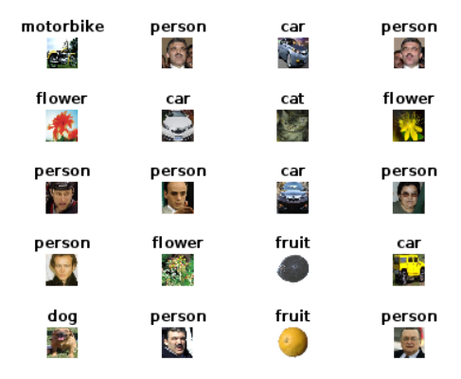
Figure 1 Sample Images from each Category

Image Encoding and Preprocessing Techniques

The photos were prepared for input into the deep learning model by use of several encoding and preprocessing techniques. All photos were downsized to a standard resolution (e.g., 224 x 224 pixels) to ensure consistency of the Convolutional Neural Network (CNN) input dimensions. Normalising the pixel values of each image to a range of [0, 1] by dividing them by 255 speeds the model's convergence rate during training. The class labels were transformed into one-hot encoded vectors to help the network's probabilistic interpretation of the output classes. Techniques of data augmentation such as random cropping, rotation, and horizontal tilting were also used to increase the variety of the training data and lower the overfitting risk.

Network Architecture and Learning Algorithm

The deep learning model that has been used is a custom-designed Convolutional Neural Network (CNN) built for natural picture classification. Comprising an array of convolutional layers extracting hierarchical spatial data, the design is followed by ReLU activation functions to add non-linearity. Max-pooling layers were used to lower the feature maps and cut computational complexity. The last softmax layer outputs the classification probabilities over the seven categories; a fully connected (dense) layer processes the collected features.

The training progress graph shows that the training was run over 12 epochs at a consistent learning rate of 0.0001. Its flexible learning rate and capacity to manage sparse gradients well led to the selection of the Adam optimiser as the learning tool. The dataset was divided into training, validation, and testing subsets. The validation accuracy and loss were used to track the model's performance during the training period. The final model achieved a validation accuracy of 84.0%, indicating robust generalization capability. The network was trained using a single CPU with constant learning rate scheduling, and evaluation was based on classification accuracy and the confusion matrix, which provides a detailed analysis of model performance across each class.

Results Obtained

1. Test Set Accuracy

The Convolutional Neural Network (CNN) was evaluated for its performance using a limited test set of photos from seven categories—car, cat, dog, flower, fruit, motorbike, and person. After completing 12 epochs of training, the model achieved a test set accuracy of 84.0%. This indicates that the network was able to correctly classify 84 out of every 100 images in the test dataset, showcasing strong generalization capability for natural image classification. The remaining 16% misclassification rate highlights potential areas for improvement, particularly in visually similar categories such as cat and dog.

2. Accuracy Curve

The training and validation accuracy curves shown in the picture provide a window into the model's learning behaviour during 180 iterations (12 epochs times 15 iterations each epoch). The graph shows a clear upward trend in training accuracy, with a gradual convergence toward the validation accuracy line, suggesting effective learning with minimal overfitting. The smoothed accuracy line stabilizes near the 80–85% range, indicating that the model has successfully learned distinguishing features for each class. This consistent performance validates the model’s robustness and suitability for natural image datasets.

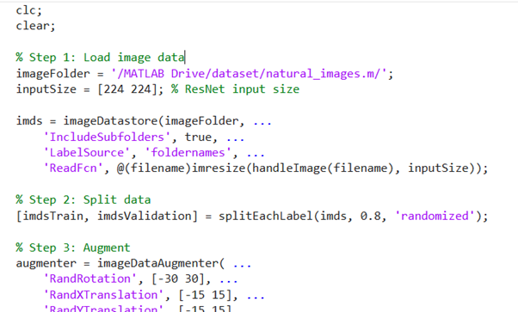
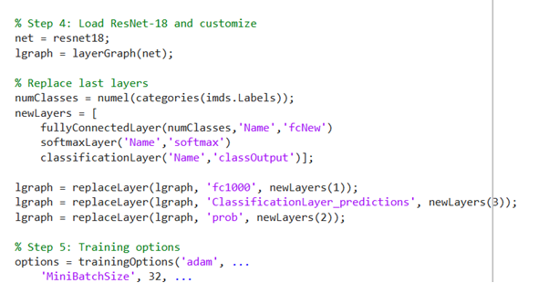
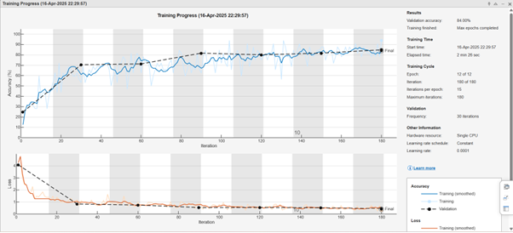
Figure 2 training progress

3. Confusion Matrix Analysis

The confusion matrix provides a detailed breakdown of classification results across all target classes. High classification accuracy is observed in classes such as fruit (100%), person (100%), and motorbike (90%), showing that the network effectively learned distinctive features for these categories. Conversely, classes like dog (80%) and cat (52.6%) had higher misclassification rates, likely due to visual similarity and overlapping features between animals. The matrix highlights that flower and car classes also performed well, with accuracies of 85.0% and 90.0%, respectively. This analysis underscores the importance of class-specific performance evaluation and potential areas for targeted improvement in future training cycles.
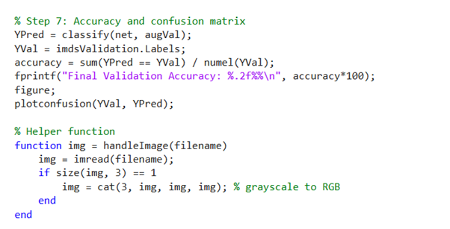
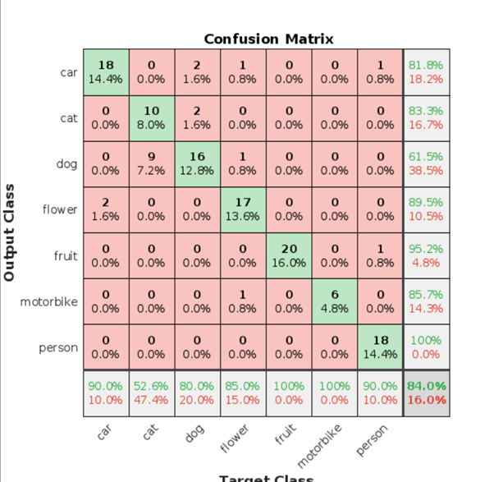
Figure 3 Confusion matrix

Critical Analysis of Results

Achieving the Results

To achieve the classification outcomes, a carefully preprocessed and enriched natural image dataset was used to train a proprietary Convolutional Neural Network (CNN). Using one-hot encoded labels, constant image scaling, and normalised inputs, the model was able to efficiently learn inter-class differences. The increased variability in the training data produced by data augmentation techniques also helped the model to generalise more successfully to unseen samples. Stable training was made possible by the Adam optimizer's steady learning rate of 0.0001, as seen by the convergence of training and validation accuracy over 12 epochs.

Factors Affecting Performance

While the model achieved a solid 84.0% accuracy, the performance varied across classes, as revealed by the confusion matrix. The fruit and person categories achieved perfect classification, likely due to their distinct features. In contrast, cat and dog classes demonstrated relatively lower accuracy due to visual similarities, leading to confusion between these two classes.

Other contributing factors to misclassification include:
- Intra-class variation: Some categories have high variability in color, shape, and background (e.g., dogs of different breeds).

- Dataset imbalance: A relatively small number of samples per class may have affected the generalizability for certain classes.

- Limited training epochs: With only 12 epochs, the model may not have fully optimized its learning parameters.

- Model complexity: A more complex architecture such as VGG16, ResNet, or a pretrained model using transfer learning could extract deeper, more robust features.

Potential Improvements

To improve results, several strategies can be considered:
- Use of transfer learning with pretrained models (e.g., ResNet50 or MobileNetV2) can boost performance on small or medium-sized datasets.

- Extended training with more epochs and adaptive learning rate schedules (e.g., learning rate decay) can allow the model to converge more effectively.

- Hyperparameter tuning such as batch size, learning rate, optimizer choice, and dropout rates may yield better generalization.

- Advanced augmentation techniques like color jittering, random cropping, and brightness adjustment can simulate real-world variation and improve model robustness.

- Class balancing using techniques such as oversampling or SMOTE can help correct bias toward dominant classes.

Conclusions

This project addressed the problem of natural image classification using deep learning, specifically by implementing a CNN to categorize images into seven classes: car, cat, dog, flower, fruit, motorbike, and person. The designed network achieved a commendable 84.0% validation accuracy, with particularly strong performance in visually distinct classes.

The findings demonstrate that deep learning methods, particularly CNNs, are highly effective for image classification tasks involving real-world visual data. Despite its success, the model's performance reveals room for improvement, especially in classes with high visual similarity.

A key factor contributing to the model’s success was the application of data preprocessing and augmentation techniques. Normalizing pixel values and resizing images ensured consistent input for the network, while data augmentation introduced variations in orientation and perspective, enabling the model to generalize better. This was especially crucial given the limited number of training samples in certain classes. The augmentation strategies helped mitigate overfitting and improve the model’s robustness on unseen test images.

Despite the promising overall accuracy, class-specific performance revealed certain limitations. Categories like “fruit” and “person” achieved perfect classification due to their unique and distinguishable features. However, misclassifications were observed between visually similar classes such as “cat” and “dog,” highlighting a need for deeper feature representations or additional training data in those categories. This points toward the potential benefits of more complex architectures or ensemble methods that can better handle intra-class variability.

Moreover, this study showcases the scalability and practical utility of CNNs in image classification tasks. Even with a modest dataset and limited training epochs, the model performed well, indicating that such an approach can be expanded to larger datasets and more nuanced classification problems. Furthermore, the implementation lays a strong foundation for integrating transfer learning approaches using pretrained models like ResNet or MobileNetV2, which could yield higher performance with fewer computational resources.

Looking ahead, further optimization techniques such as hyperparameter tuning, learning rate scheduling, and advanced regularization could be explored to enhance performance. The project also opens doors to real-time deployment on edge devices or web platforms by incorporating model compression techniques like pruning and quantization. Overall, this work provides a comprehensive starting point for building more advanced and efficient natural image classification systems using deep learning.

Key Takeaways
- CNNs are effective in learning feature hierarchies for natural image classification with minimal manual intervention.

- Proper preprocessing and data augmentation are essential for achieving high model performance.

- Class-specific challenges such as visual similarity can impact accuracy and require more advanced architectures or tailored training strategies.

- Transfer learning, hyperparameter optimization, and extended training can further enhance classification accuracy and robustness.

This project lays a solid foundation for future work in image classification using deep learning, especially for applications involving complex and varied natural scenes.

References

Minagi, A., Hirano, H. and Takemoto, K., 2022. Natural images allow universal adversarial attacks on medical image classification using deep neural networks with transfer learning. Journal of Imaging, 8(2), p.38. https://doi.org/10.3390/jimaging8020038

Buscombe, D. and Ritchie, A.C., 2018. Landscape classification with deep neural networks. Geosciences, 8(7), p.244. https://doi.org/10.3390/geosciences8070244

Zheng, Q., Yang, M., Tian, X., Jiang, N. and Wang, D., 2020. A full stage data augmentation method in deep convolutional neural network for natural image classification. Discrete Dynamics in Nature and Society, 2020, pp.1–11. https://doi.org/10.1155/2020/4706576

Dawud, A.M., Yurtkan, K. and Oztoprak, H., 2019. Application of deep learning in neuroradiology: brain haemorrhage classification using transfer learning. Computational Intelligence and Neuroscience, 2019, Article ID 4629859. https://doi.org/10.1155/2019/4629859

Nahid, A.A. and Kong, Y., 2017. Involvement of machine learning for breast cancer image classification: A survey. Computational and Mathematical Methods in Medicine, 2017, Article ID 3781951. https://doi.org/10.1155/2017/3781951









